**Pom.xml**

<?xml version="1.0" encoding="UTF-8"?>

<project xmlns="http://maven.apache.org/POM/4.0.0" xmlns:xsi="http://www.w3.org/2001/XMLSchema-instance"

xsi:schemaLocation="http://maven.apache.org/POM/4.0.0 https://maven.apache.org/xsd/maven-4.0.0.xsd">

<modelVersion>4.0.0</modelVersion>

<parent>

<groupId>org.springframework.boot</groupId>

<artifactId>spring-boot-starter-parent</artifactId>

<version>2.7.10</version>

<relativePath/> <!-- lookup parent from repository -->

</parent>

<groupId>com.cdac</groupId>

<artifactId>Spring-Boot-Welcome-App</artifactId>

<version>0.0.1-SNAPSHOT</version>

<name>Spring-Boot-Welcome-App</name>

<description>Welcome project for Spring Boot</description>

<properties>

<java.version>11</java.version>

</properties>

<dependencies>

<dependency>

<groupId>org.springframework.boot</groupId>

<artifactId>spring-boot-starter-web</artifactId>

</dependency>

<dependency>

<groupId>org.springframework.boot</groupId>

<artifactId>spring-boot-starter-test</artifactId>

<scope>test</scope>

</dependency>

</dependencies>

<build>

<plugins>

<plugin>

<groupId>org.springframework.boot</groupId>

<artifactId>spring-boot-maven-plugin</artifactId>

</plugin>

</plugins>

</build>

</project>

**WelcomeController.java**

package com.cdac.controller;

import org.springframework.web.bind.annotation.GetMapping;

import org.springframework.web.bind.annotation.RestController;

*@RestController*

public class WelcomeController {

*@GetMapping* (value = {"/welcome"})

public String sayWelcome() {

return "<h1>Welcome to my Spring Boot Project</h1>";

}

}

**SpringBootWelcomeAppApplication.java**

package com.cdac;

import org.springframework.boot.SpringApplication;

import org.springframework.boot.autoconfigure.SpringBootApplication;

*@SpringBootApplication*

public class SpringBootWelcomeAppApplication {

public static void main(String[] args) {

SpringApplication.*run*(SpringBootWelcomeAppApplication.class, args);

}

}

**Project Structure**

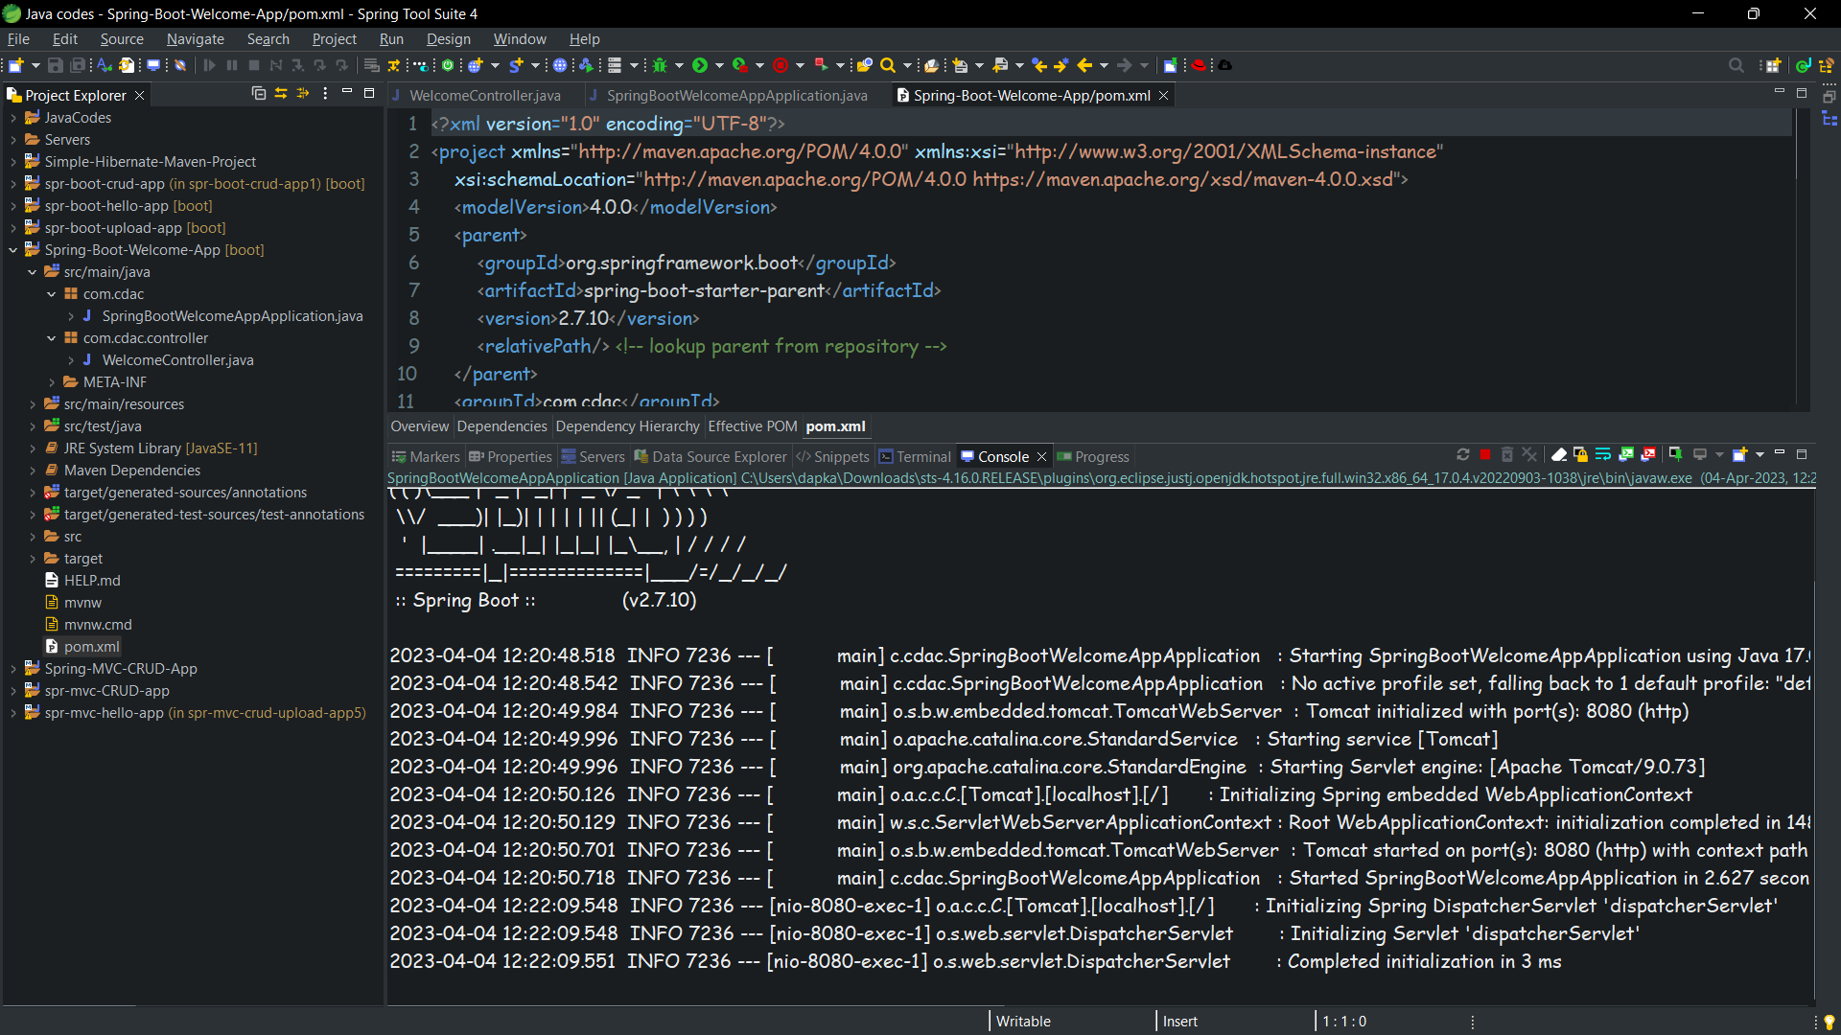

**Web Screenshot**

